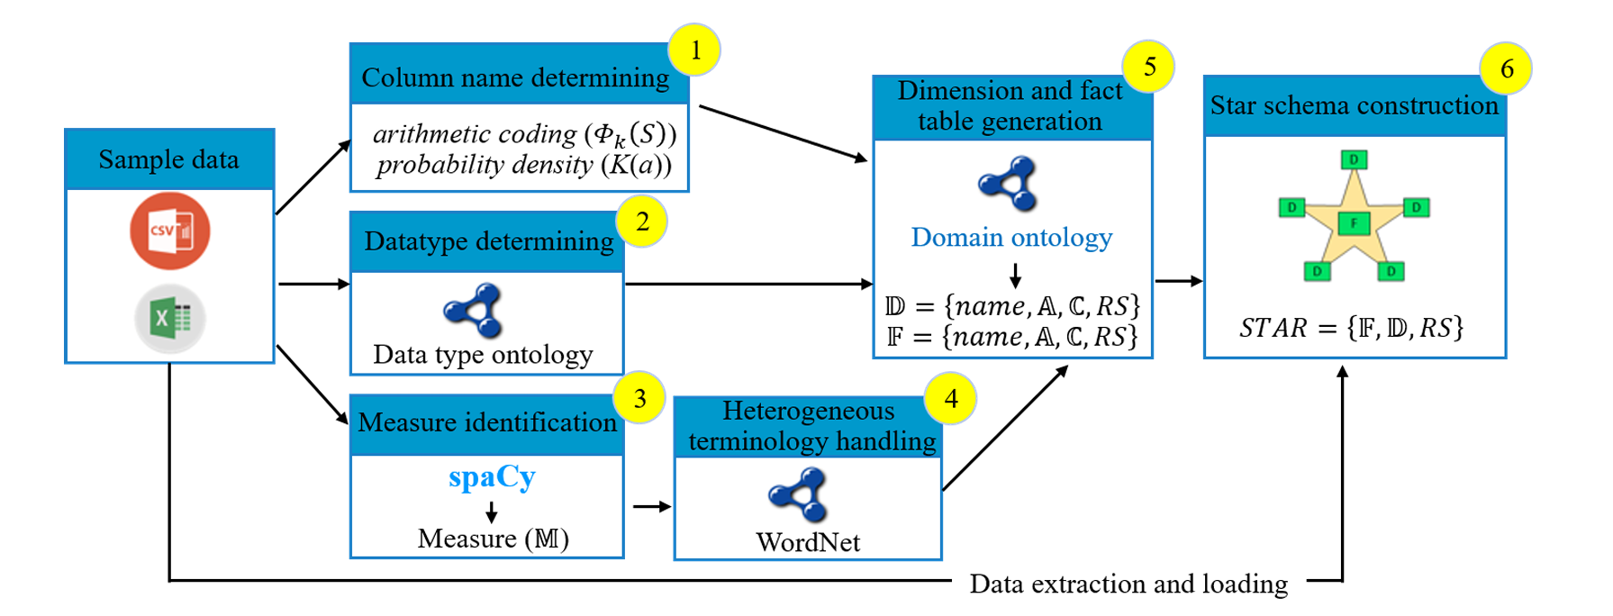

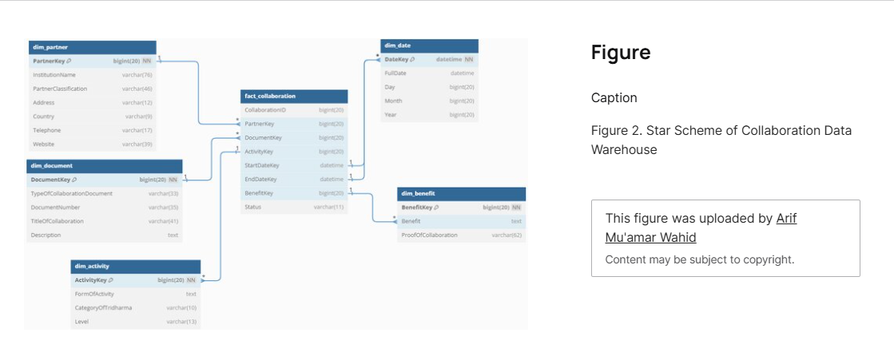

<https://www.researchgate.net/publication/387502723_ENHANCING_COLLABORATION_DATA_MANAGEMENT_THROUGH_DATA_WAREHOUSE_DESIGN_MEETING_BAN-PT_ACCREDITATION_AND_KERMA_REPORTING_REQUIREMENTS_IN_HIGHER_EDUCATION/figures>

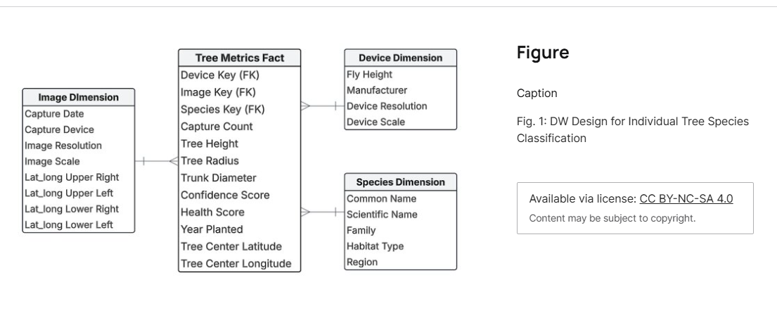

<https://www.researchgate.net/publication/388920234_Data_Warehouse_Design_for_Multiple_Source_Forest_Inventory_Management_and_Image_Processing/figures>

**Not valid**

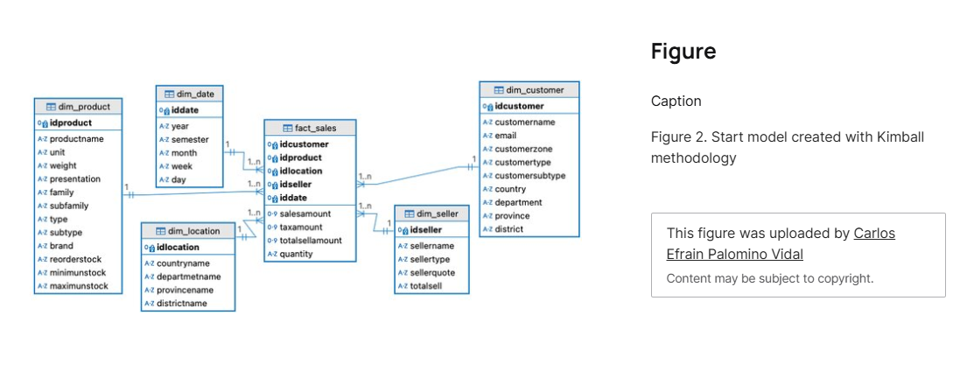

<https://www.researchgate.net/publication/386571738_Kimball_data_warehouse_for_the_sales_analysis_process_in_a_manufacturing_business_in_Peru/figures>

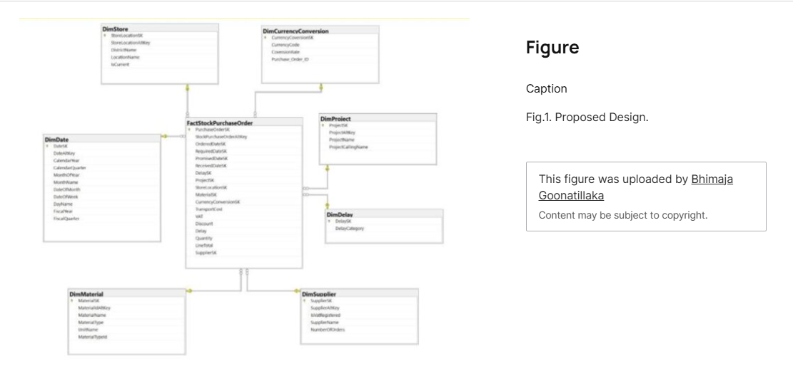

<https://www.researchgate.net/publication/388553974_Data_Warehouse_Design_for_Construction_Material_Purchase_Order_Management/figures> **Not found**

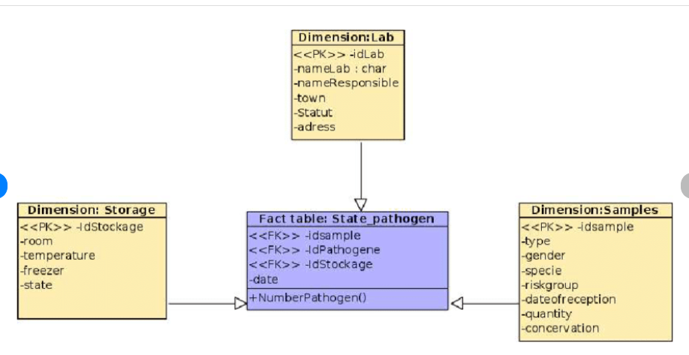

<https://www.researchgate.net/publication/351934181_A_Data_Warehouse_Design_for_Dangerous_Pathogen_Monitoring>

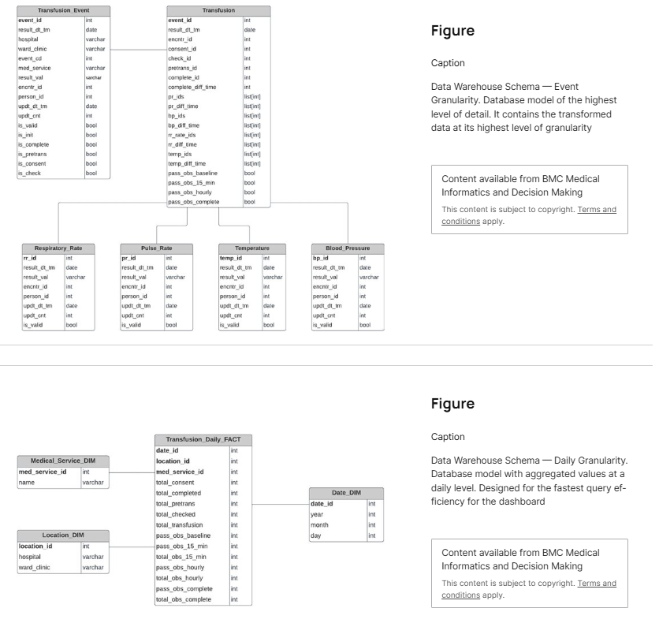

<https://www.researchgate.net/publication/386047786_Creating_a_data_warehouse_to_support_monitoring_of_NSQHS_blood_management_standard_from_EMR_data/figures> **waiting**

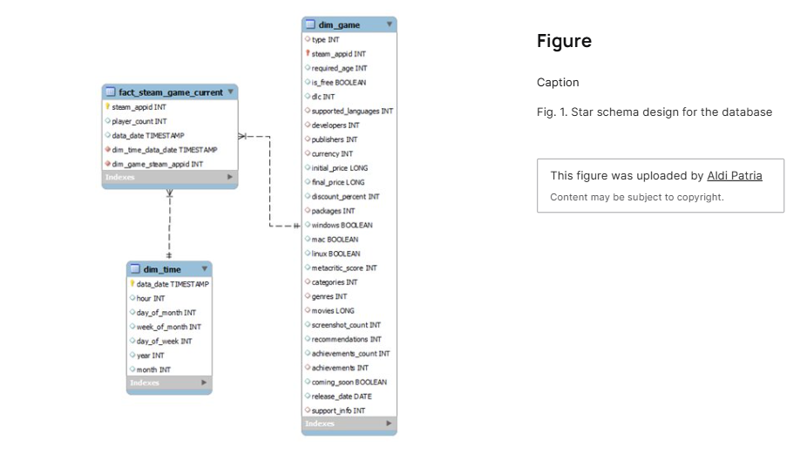

<https://www.researchgate.net/publication/388564184_Analyzing_Steam_User's_Behavior_Using_Data-Warehouse_Method/figures>

<https://steamcommunity.com/dev> using api

Adventure works

<https://big.csr.unibo.it/downloads/caf/AdventureWorks/AdventureWorksDW2008.pdf>

Amazon page 47

<https://docs.aws.amazon.com/pdfs/redshift/latest/dg/redshift-dg.pdf#c_high_level_system_architecture>

**Very important “Orange Digital center”:**

**https://github.com/codsalah/Orange-DC-big-data-intern/tree/main**